
Subject: Programming with Java
ASSIGNMENT No : 27
TITLE: Develop a Java application demonstrating socket programming for communication between a client and a server.

Name: Avdhoot Mohite Class: CSE A2
PRN: 25070122056 Batch:25-29

Problem Statement
Develop a Java application demonstrating socket programming for communication between a client and a server.
Learning Objectives
To establish communication between client and server using Java sockets.
Theory
Socket programming enables communication between computers over a network using TCP/IP protocols. Java provides the Socket class for client-side communication and the ServerSocket class for server-side communication. A server listens for client requests on a specific port, while clients establish connections using the server's IP address and port number. Once connected, data is exchanged using input and output streams. Socket programming supports reliable communication between distributed systems and is widely used in chat applications, online gaming, file transfer systems, remote monitoring, and client-server architectures.
Exercise
- Create a simple client-server chat application using sockets.

SERVER
CODE:
import java.io.*;
import java.net.*;
import java.util.Scanner;

public class assignment27a_server {
public static void main(String[] args) {

try (ServerSocket server = new ServerSocket(5000)) {
System.out.println("Server started...");
System.out.println("Waiting for client...");

try (
Socket socket = server.accept();
BufferedReader in = new BufferedReader(
new InputStreamReader(socket.getInputStream()));
PrintWriter out = new PrintWriter(
socket.getOutputStream(), true);
Scanner sc = new Scanner(System.in)
) {
System.out.println("Client connected!");

while (true) {
String message = in.readLine();

if (message == null || message.equalsIgnoreCase("bye")) {
System.out.println("Client disconnected.");
break;
}

System.out.println("Client: " + message);

System.out.print("Server: ");
String reply = sc.nextLine();
out.println(reply);

if (reply.equalsIgnoreCase("bye")) {
break;
}
}
}

} catch (IOException e) {
System.out.println("Server Error: " + e.getMessage());
}
}
}

CLIENT

import java.io.*;
import java.net.*;
import java.util.Scanner;

public class assignment27a_client {
public static void main(String[] args) {

try (
Socket socket = new Socket("localhost", 5000);
BufferedReader in = new BufferedReader(
new InputStreamReader(socket.getInputStream()));
PrintWriter out = new PrintWriter(
socket.getOutputStream(), true);
Scanner sc = new Scanner(System.in)
) {
System.out.println("Connected to server!");

while (true) {
System.out.print("Client: ");
String message = sc.nextLine();

out.println(message);

if (message.equalsIgnoreCase("bye")) {
break;
}

String reply = in.readLine();

if (reply == null || reply.equalsIgnoreCase("bye")) {
System.out.println("Server disconnected.");
break;
}

System.out.println("Server: " + reply);
}

} catch (IOException e) {
System.out.println("Client Error: " + e.getMessage());
}
}
}

OUTPUT:

Server_Side:
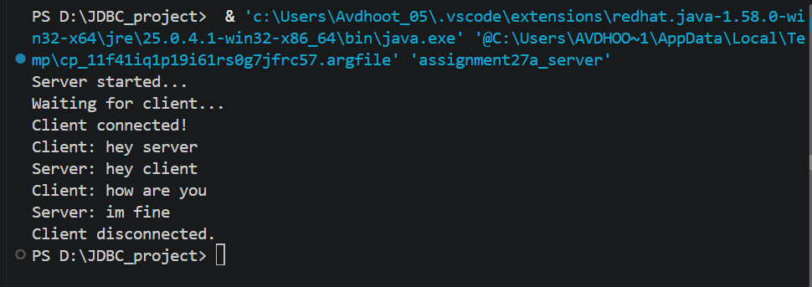
Client_side:
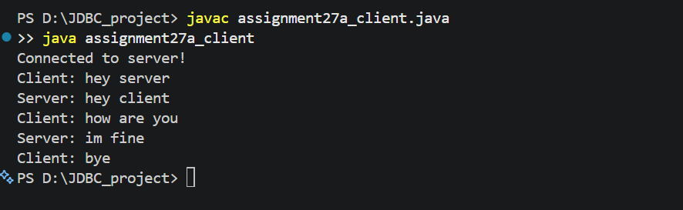
- Create a Java program using socket programming where the client sends a message to the server, and the server returns the same message back (echo system).
CODE:
SERVER:
import java.io.*;
import java.net.*;

public class assignment27b_server {
public static void main(String[] args) {

try (ServerSocket server = new ServerSocket(6000)) {

System.out.println("Echo Server Started...");
System.out.println("Waiting for client...");

try (
Socket socket = server.accept();
BufferedReader in = new BufferedReader(
new InputStreamReader(socket.getInputStream()));
PrintWriter out = new PrintWriter(
socket.getOutputStream(), true)
) {
System.out.println("Client Connected!");

String message;

while ((message = in.readLine()) != null) {
System.out.println("Received: " + message);

out.println(message);

if (message.equalsIgnoreCase("bye")) {
break;
}
}

System.out.println("Connection Closed.");
}

} catch (IOException e) {
System.out.println("Server Error: " + e.getMessage());
}
}
}

CLIENT:

import java.io.*;
import java.net.*;
import java.util.Scanner;

public class assignment27b_client {
public static void main(String[] args) {

try (
Socket socket = new Socket("localhost", 6000);
BufferedReader in = new BufferedReader(
new InputStreamReader(socket.getInputStream()));
PrintWriter out = new PrintWriter(
socket.getOutputStream(), true);
Scanner sc = new Scanner(System.in)
) {
System.out.println("Connected to Echo Server!");

while (true) {
System.out.print("Enter message: ");
String message = sc.nextLine();

out.println(message);

String response = in.readLine();

if (response == null) {
System.out.println("Server disconnected.");
break;
}

System.out.println("Echo from Server: " + response);

if (message.equalsIgnoreCase("bye")) {
break;
}
}

} catch (IOException e) {
System.out.println("Client Error: " + e.getMessage());
}
}
}

OUTPUT:
SERVER_SIDE:
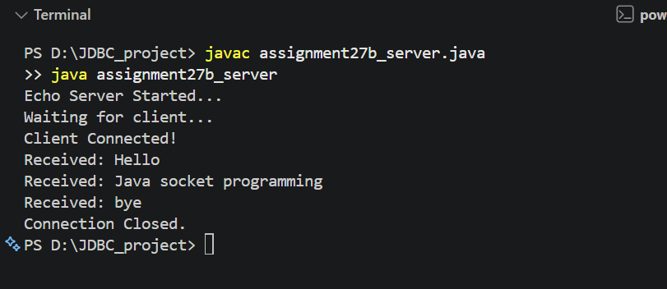
CLIENT_SIDE:
